RAJVIR KAUR (23059313)

LAB 2

PROGRAMMING CONCEPTS 2

ANSWERS.

CREATE DB NAMED curd_db in MYSQL workbench.

CREATE TABLE USERS

Main.java

SECTION A: **Design and GUI**

SECTION B: **Database Connection**

SECTION C: **Data Models and ORM**

SECTION D: **Open JDBC Jar**

SECTION E: **Load Data in Table View**

SECTION F: **Insert Data into Database**

Here I insert 2 values:

**

**Here, I update name ruksana with mandeep:**

SECTION H: **Delete Data from Database**

Here, I delete Mandeep from the list:

OUTPUT IN MYSQL:

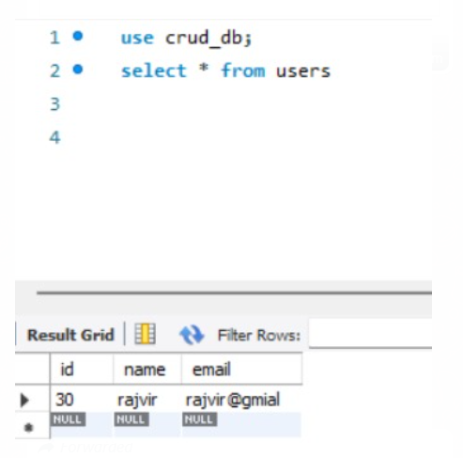

SECTION I: **GitHub and Documentation**

Link to GitHub: [Rajvirsault/rajvirkaur_lab2](https://github.com/Rajvirsault/rajvirkaur_lab2)